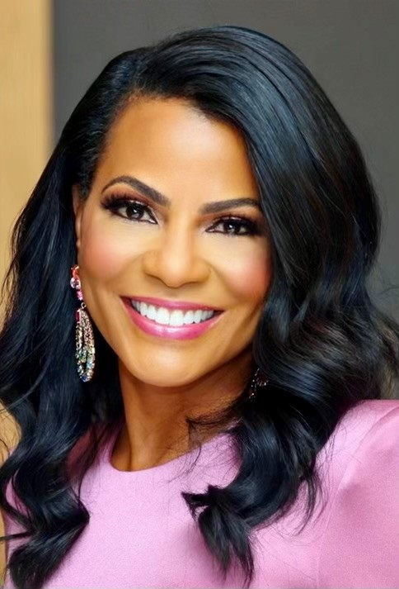
For more information or to request public appearances or speaking engagements contact: Aamira Bussey Bellamy, 734.546.1476 and busseya@umich.edu.

BIOGRAPHY – 2025
Rhonda Walker has been helping Detroiters get motivated and ready for the day with her incredible energy, enthusiasm, impeccable style, and passion for her hometown for the past 27 years. A confessed morning person, this award winning talented and versatile journalist starts her day at 2:00 am to co-anchor the weekday morning and noon newscasts at WDIV-Local 4 News. A position she’s held since 2003. This award-winning journalist is known for her compassionate storytelling and keen interviewing instincts with top local and national leaders to families struggling to make ends meet. But for those who only know Rhonda Walker the Anchor Person, there is so much more.
Throughout her life, Rhonda has been committed to serving the Metro Detroit community. Rhonda’s passion for giving back and uplifting others is shown by over 50 appearances she makes throughout the year with motivational speaking and in support of charitable efforts. She is well established not only as a leader in her profession but also for service to the greater Detroit Community, especially in youth and women’s empowerment, homelessness, health and wellness and philanthropy.
Over the past decade Rhonda has been recognized by her peers, and received awards and honors from over 50 different community, corporate, and professional organizations, including:
• 20 times for her Community Service including honored nationally with the -
2024 Presidential Joseph R. Biden Lifetime Achievement Award for Volunteer Service
2023 National Daily Point of Light Award for Inspiring Service Work
2022 Michigan Governor’s Service Award – Youth Impact Award
2019 Congressional Black Caucus Michigan Delegation Community Change Agent Award
2018 National Association of Black Journalists (NABJ) Angelo B. Henderson Community Service Award

Other Recent Honors include the –
2025 Michigan Chronicle Applause Magazine Stand Out Black Non-Profit Leader in SE Michigan
2023 The Soul of Philanthropy Exhibit Honor in the Detroit Historical Museum
2022 Stellantis STAAND – Standing Ovation Award for Community Impact
2021 Crain’s Detroit Business Notable Non-Profit Board Member
2019 Inductee - Catch Charity Hall of Fame for Extraordinary Charitable Contributions
2019 Dr. Gerald K. Smith Humanitarian Award from Black Family Development, Inc.
2019 Northwood University Distinguished Woman Award
2019 Fiat Chrysler Automobiles - Standing Ovation Award
2019 Neal Shine Award for Excellence in Media Commitment to Philanthropy

• 8 times for her work related to empowering youth and mentoring
• 17 times for leadership and distinguished service; and
• 10 times for professional media related awards
Her scores of awards and numerous accolades also include 2025 Detroit TEDx speaker (From Doubt to Determination: The Journey of Self Belief)
12 consecutive years of “Best News Anchor Awards” from Hour Detroit Magazine (2014-2025). And Best News Anchor Awards from the Michigan Chronicle (2016-2018) and Michigan Chronicle Women of Excellence Award. Additional recognition includes honors from the City of Detroit (Spirit of Detroit Award), NAACP (Great Expectation Award), General Motors, Ford Motor Company, News/Talk WJR 760am, YWCA, NAWBO, Michigan Women’s Foundation and the Detroit Rescue Mission Ministries.
Rhonda is a Board Trustee at Harper/Hutzel and Detroit Receiving Hospitals and an active member of Alpha Kappa Alpha Sorority, Inc., Renaissance Chapter of the Links, Inc. and Girl Friends, Inc.
Rhonda is also the founder and president of the Rhonda Walker Foundation, now in its 22nd year (February 2025). To date the foundations award-winning, comprehensive five-year Girls into Women education, career and personal development, mentoring and college prep programming has resulted in 100% high school graduation and college enrollment rates among the inner-city teen girls who complete the program, along with a 95% college graduation rate. Rhonda helped launch its comprehensive college prep initiative that provides year-round tutoring in all subjects, ACT/SAT test prep courses starting in the 8th through 12th grade and cross-country college tours, the award winning Give and Get Fit program in 2011 to promote healthy lifestyles among the RWF teens and families and raise community awareness about health, fitness and nutrition. The foundation also launched it’s after school RWF Academy at 5 partner middle schools in spring 2019, renaming it to the Empowering Her Success Academy in 2025 in partnership with Stellantis. For more information about the foundation visit http://rhondawalkerfoundation.org/

Born in Detroit and raised in Lansing, Rhonda holds a degree in Communications from Michigan State University. In her spare time Rhonda is an avid golfer and loves to travel with her husband Jason, shop, dine out, enjoy Michigan summers, volunteer and spend quality time with family and friends.

