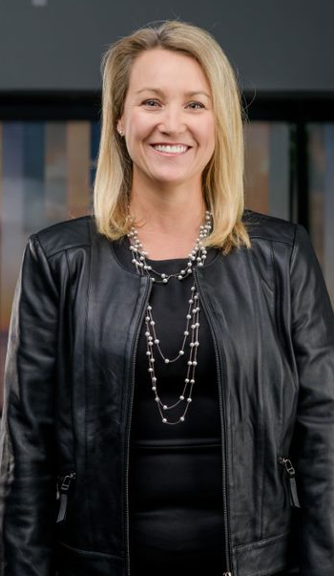
Jaymi Wilson is Gentherm’s Senior Vice President and General Manager, North America Automotive
Jaymi is responsible for growth and profitability of the automotive business in North America, managing customer relationships, product development, manufacturing, and delivery of quality products. She also leads global sales operations, marketing, and corporate communications across the company. Since joining Gentherm in 2013, Jaymi has assumed increasing responsibility, where she has served in Senior Vice President role of Strategy, Sales Marketing, and Corporate Communications. Prior to that she was Vice President and General Manager of Gentherm’s Medical Business.
Her career in the automotive industry has spanned manufacturing, engineering, product line, sales, strategy, and corporate development at Visteon, SMR Automotive Global, and Gentherm.
Jaymi Wilson
Gentherm Inc.

Senior Vice President and General Manager, North America Automotive
Jaymi earned a Bachelor of Science degree in mechanical engineering from the University of Michigan and a Master of Business Administration from Eastern Michigan University.

