Presenter Biography:
Gianna Ferrarotti, Vice President

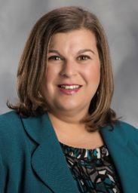
VP, Human Resources Business Partner & Learning
email: Gianna.Ferrarotti@corewellhealth.org
Gianna is vice president, human resources business partner for Corewell Health East and leads learning & development for the system.
In this role, she is responsible for the development and execution of the human resources strategy for Corewell Health East, leads a team of HR business partners and provides strategic direction that aligns with system objectives and goals. Gianna also leads the Learning & Development team for Corewell Health where she is responsible for the development and delivery of impactful, system-wide learning programs and experiences for all team members.
With over 25 years of human resources experience, Gianna joined Corewell Health in 2018, where she served as vice president talent management & organizational effectiveness. In this role, she led talent acquisition, learning, engagement and rewards and recognition for Beaumont Health. Gianna came to Corewell Health from Ohio Health in Columbus, Ohio, where she served as system director of learning and director, HR business partner.
She earned a bachelor’s degree from Central Michigan University and a master’s degree in business administration from Ohio University.

