Family Futures Office Location
Riverview Center
678 Front Avenue NW, Suite 210
Grand Rapids, MI 49504

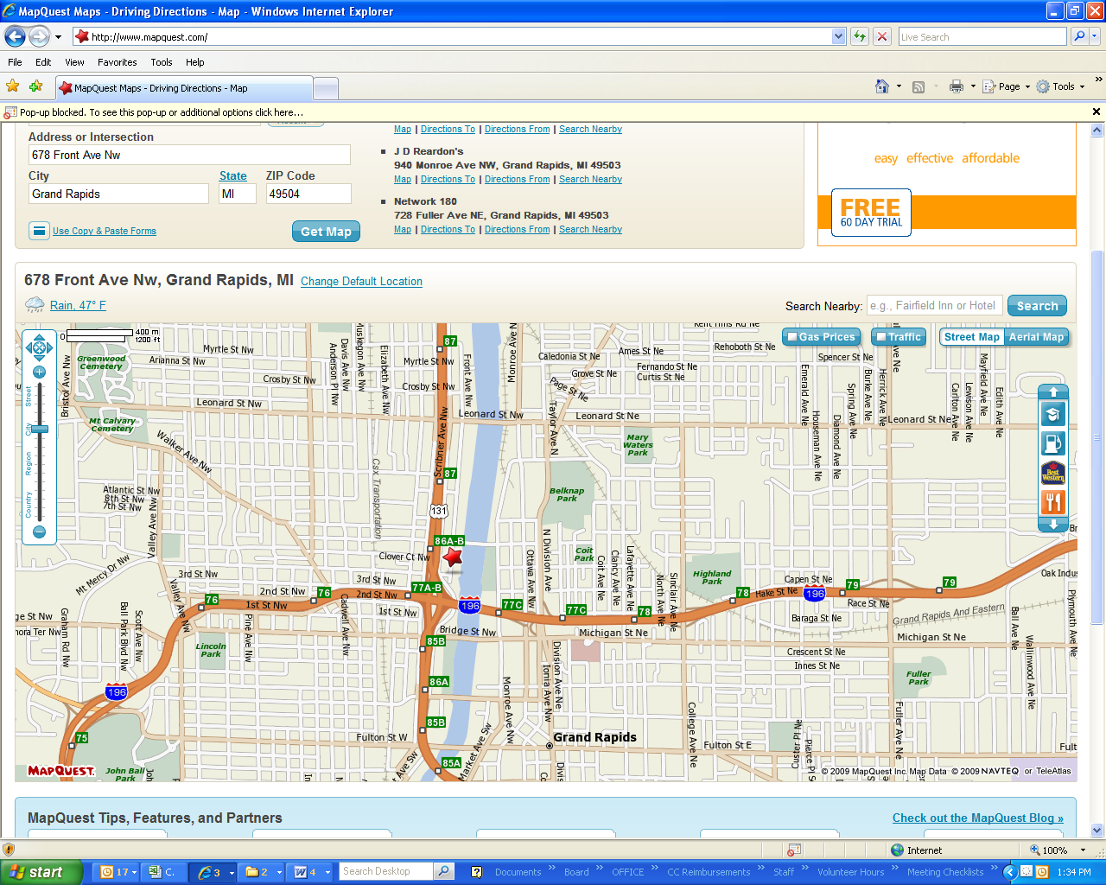

Welcome to our office!
Free parking is available in the large parking lot across the street from the Riverview Center.
Park across the street at the south end - near Plante & Moran (tall silver building.)
Enter at the South entrance (“Riverview South” above glass doors).
Take the stairs or the elevator to the second floor.
Our office is the second office on the left - Suite 210.
Please call 616.454.HOPE (4673) if you have any questions.

